HubSpot Contact Cleanup- Phase 1

1. Purpose
This SOP provides clear, step-by-step guidance for how CSS team members should review and update HubSpot contact records that are tagged with the following Customer Types:
- Non-Dental
- International
- International Dealer
The goal of Phase 1 is to ensure every active contact is assigned to the correct Customer Type so downstream teams can rely on accurate data for reporting, routing and communication. Consistent queue maintenance protects data quality and keeps cross-team workflows running smoothly.

D365 is the system of record for customer data. HubSpot is not currently synced with D365.

2. Scope & Rules
Scope of Responsibility
Customer Service (CSS) team members are responsible for reviewing and completing HubSpot contact records that appear in the designated cleanup queue.
Specifically, CSS team members are responsible for:
- Reviewing each contact in the provided list view
- Confirming or correcting the following, when information is clearly available:
  - Contact name formatting
  - Contact owner
  - Customer Type
- Updating basic contact fields only when information can be confidently verified
Queue Review Cadence
- CSS team members are expected to review the
“Non-Dental, International and International Dealer” contact queue every day as part of daily workflow.
- During each review, all contacts currently in the queue should be worked
- CSS team members are not required to wait for escalated contacts to be resolved before continuing work
- If the queue is empty at the time of review, no action is required until the next scheduled review
Out of Scope Activities
The following actions are outside the scope of this process and should not be performed:
- Creating new Customer Types
- Guessing or assuming a Customer Type
- Deleting contacts outside the approved Phase 1 criteria
- Overwriting data that cannot be verified with available information
If a Customer Type cannot be confidently determined, CSS team members must follow the escalation process outlined later in this SOP.
At this point, every contact will follow ONE path:
✅ Update + Classify = DONE

️ Unable to Classify Escalate + move on

❌ Should not exist Delete and return to queue

3. Required Systems
You will use both systems during this process:
- HubSpot (primary system)
- D365 (reference system)

4. Your Work Queue (Where to Start)

Log In
- Log in to HubSpot

Open the Contact Queue
- Navigate to Contacts
- Click Add View
- Search for and select the view named: “Non-Dental, International and International Dealer”
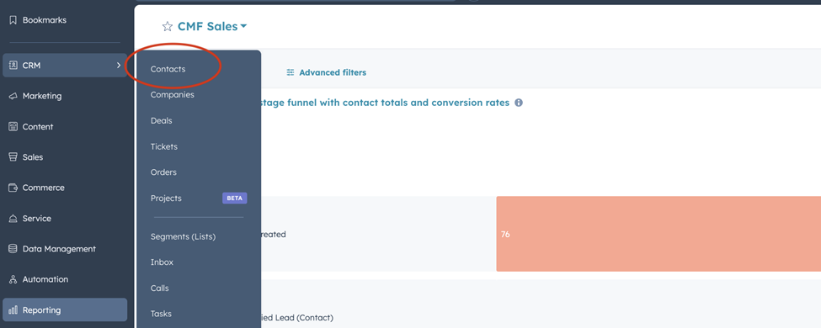
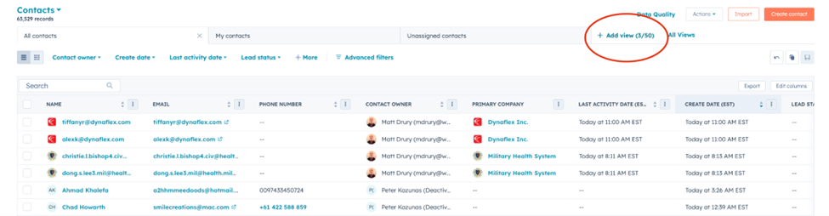
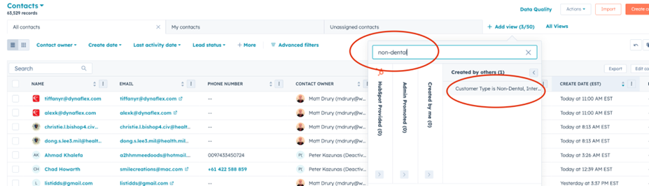

This list view is your assigned queue.
- Every contact in this view must be reviewed.
- Contacts will automatically disappear from the list once completed.
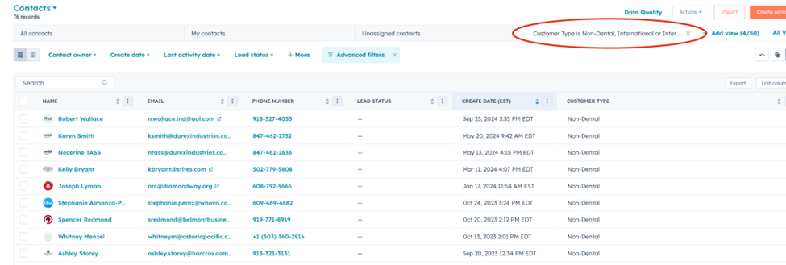

Contact Review Checklist (Do This Every Time)
Work one contact at a time. Complete all steps before moving to the next contact.
Step 1: Open the Contact Record
- Click a contact name to open the Contact Record.
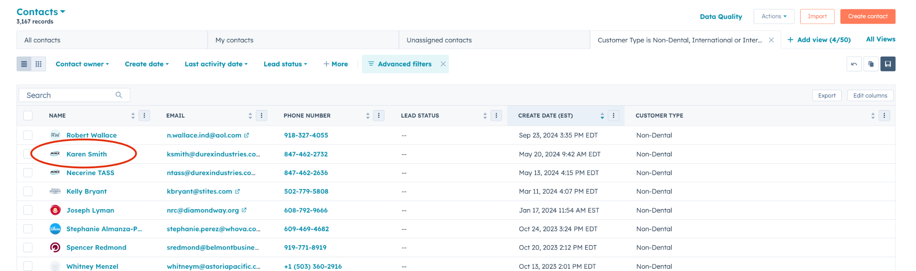

Step 2: Confirm the Contact Should Exist
Before making any updates, review the contact to determine whether it should remain in HubSpot.
Delete the contact using Restorable Delete if the contact is:
- Spam or system-generated
- Test or training contact
- Duplicate (same name + same email)
- Personal contact added in error
If deletion is required:
- Stop further review immediately
- Do not continue to other steps
- Follow the Contact Deletion (Restorable Delete) instructions
- Return to the contact queue after deletion
If the contact should remain in HubSpot, continue to Step 3.
Step 3: Name Review
- Ensure the contact’s name is:
  - Properly capitalized
  - Spelled correctly
- Edit the name only if clearly incorrect
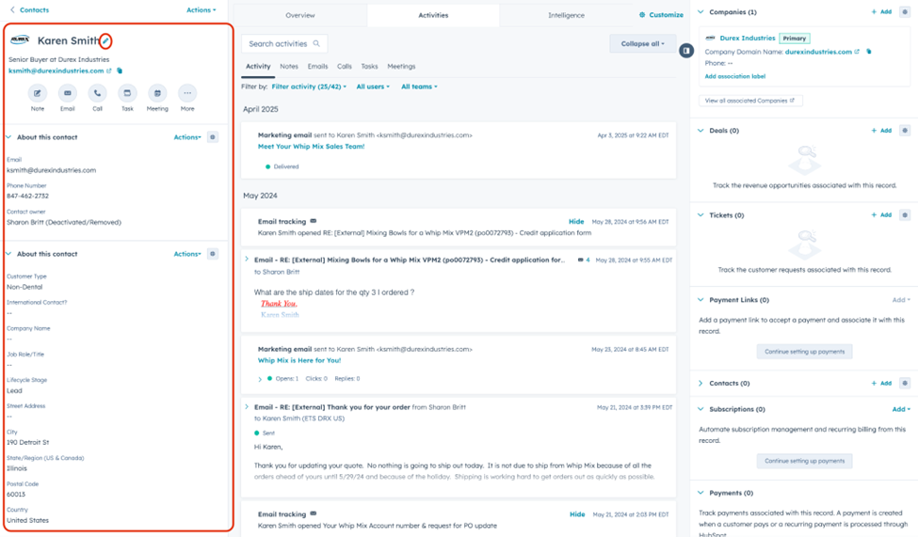

Step 4: Contact Owner Review
If the contact already has an active Contact Owner, no change is required.
If the Contact Owner is blank (or inactive), assign a CSS team member using the rules below:
  - Last name A-M Laura
  - Last name N-Z Matt
  - Any contact with International or International Dealer Customer Type Laura

Step 5: Data Updates
Only update data when clearly verified (D365 or other reliable source).
HubSpot stores information in two types of records:
- Contact = a person (individual record)
- Company= a business (shared across multiple contacts)
Each field you edit is called a property.
- If it describes the person Update the Contact
- If it describes the business Update the Company
A. Contact Updates (Person Information)
A Contact record represents a single person.
Update contact info only if it is incorrect and verified; do not guess or infer missing details.
Allowed Updates (Only if verified):
- First Name
- Last Name
- Email
- Job Title
- Direct Phone Number (person)
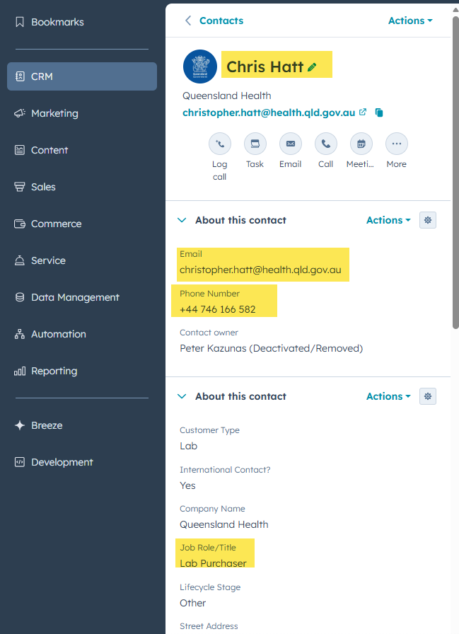
DO NOT UPDATE:
- Company Name (on Contact)
- Company Address
- Company Phone
- Company Domain
These belong to the Company record, not the contact.

B. Company Name Updates (Business Information)
A Company record represents a business and is shared across multiple contacts.
Update the company name only when the company record itself is incorrect.
Do not update if the contact has simply changed companies.
How to Update Company Name
1. Locate the Company Section (Right Side Panel)
- Look at the right-hand side of the Contact record
- Find the section labeled Company
- The company name here is clickable
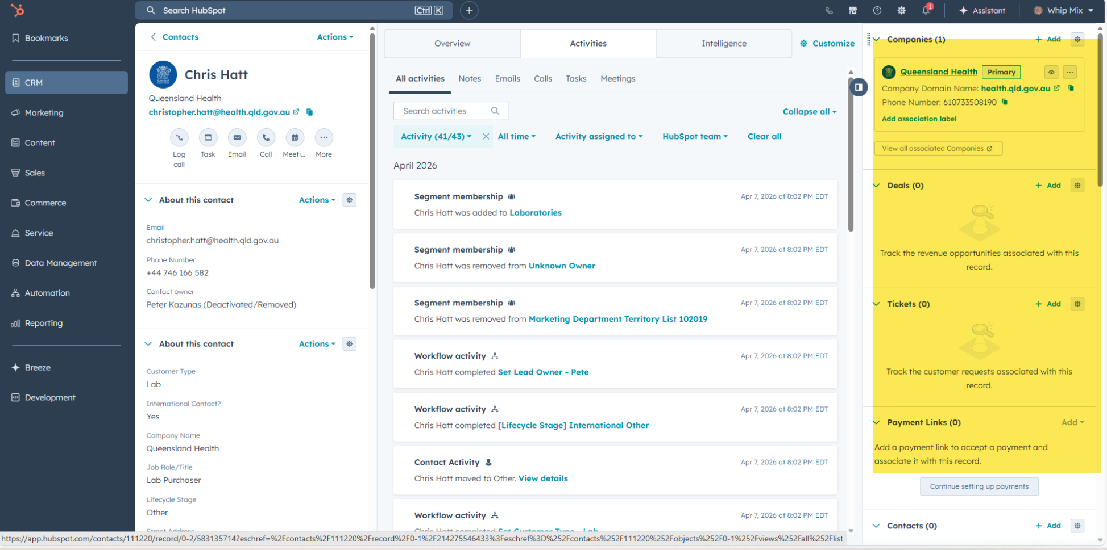
2. Open the Company Record
- Click the Company name in the right panel (blue link)
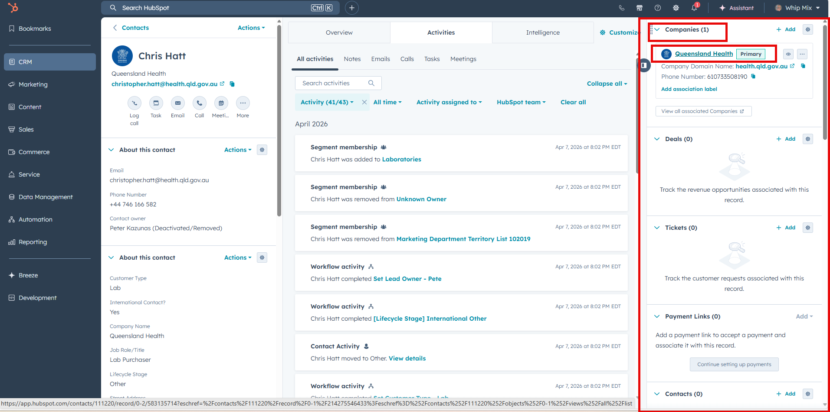
3. Edit the Company Name
- On the Company record, locate the Company name (Name property)
- Update the name to the correct value
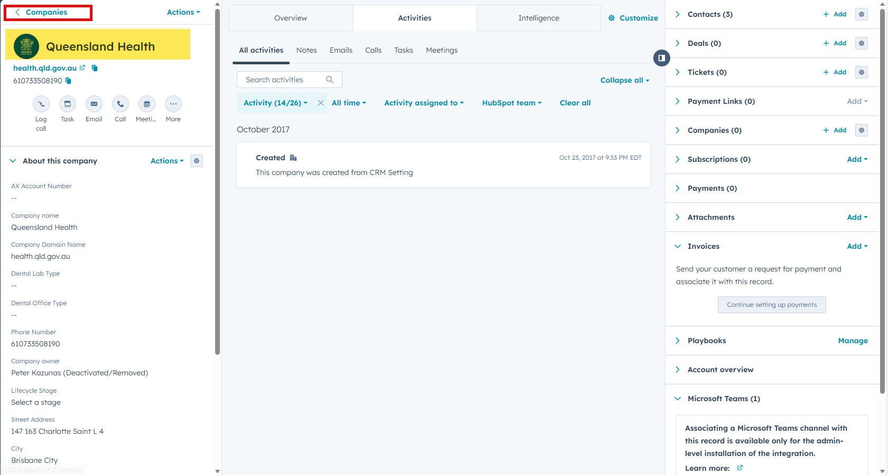

Remember:
- Always update company name by clicking into the Company record
- Do not edit the “Company name” field on the contact
  - If you are typing into a field on the Contact record, you are in the wrong place.
You must click into the company record to make this update.

If the Contact is linked to the wrong company, this is a relationship update, not a company name update. Follow Appendix A: Company Relationship Updates.

Step 6: Customer Type Classification (Most Important Step)
Select the single Customer Type that best applies to the contact.
HubSpot saves automatically once a Customer Type is selected. No additional action is required.
Customer Type | Description
Doctor | Dentist, clinician, hygienist, prosthodontist, any contact who works at the doctor or clinician's office - office manager, billing, etc.
Lab | Lab owner, lab technician, lab support team, purchaser, lab/department manager
School | Faculty, dean, bookstore manager, administrative assistant, Pankey, Dawson, any contact who works at the school or university
Student | A contact currently enrolled in a school program
Dealer/Sales Rep | Any contact who works at a dealer - Benco, Patterson, Midwest, etc.
Government | Government agency or official contact
Manufacturer | OEM or partner manufacturer
Partner | LMT, JDT, NADL, ADEA, DTA, or other industry partners

How to Determine the Correct Customer Type
Use the following decision order to determine the most appropriate Customer Type. You
may stop once the Customer Type is clear.
- D365 record
- Job Title (in HubSpot)
- Company website (via email domain or web search)
- Email domain (e.g. .edu, dealer domain)
- Activity history or past emails
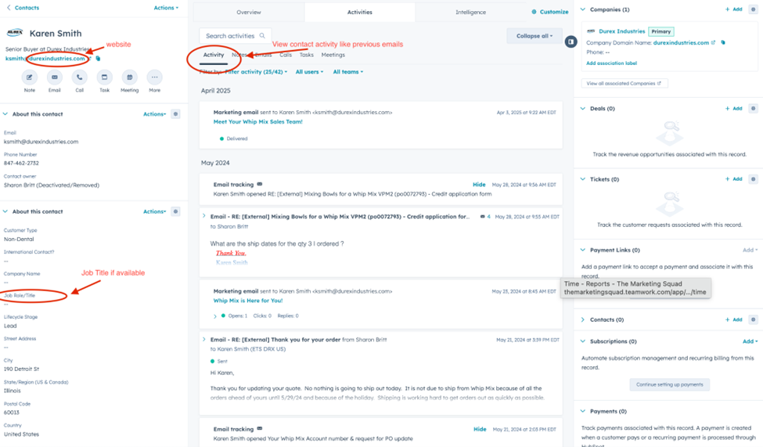

Updating the Customer Type
- Locate the Customer Type property
- Click the current value (Non-Dental, International, or International Dealer)
- Select the correct Customer Type
HubSpot saves automatically.
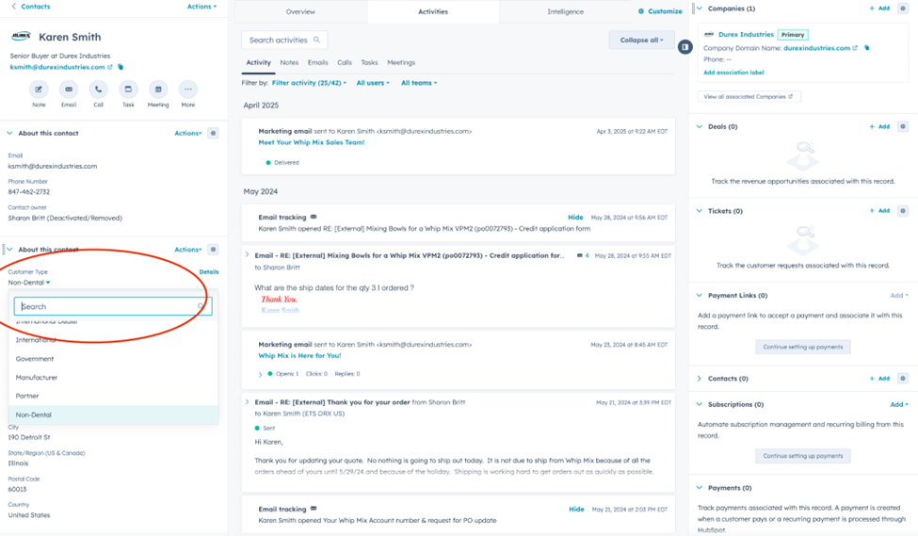

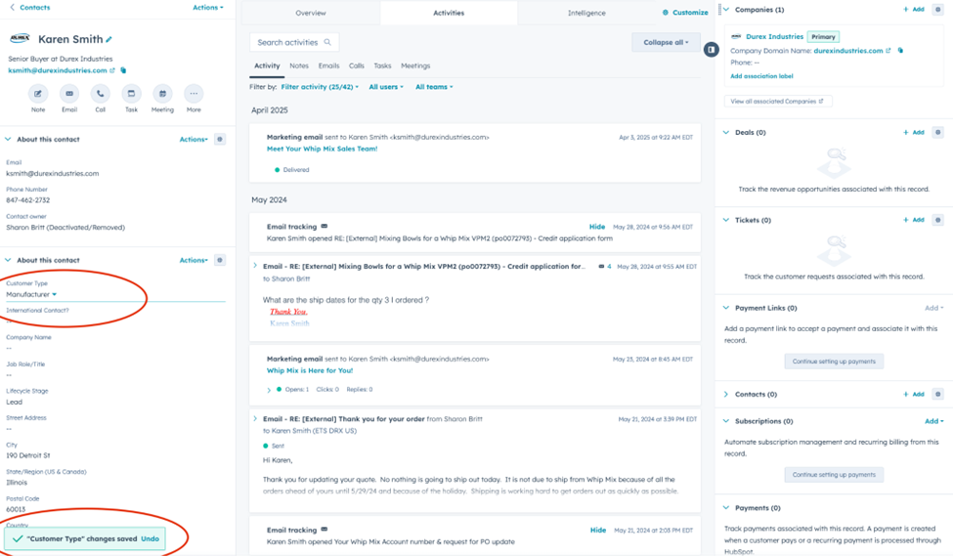

If You CANNOT Determine the Customer Type
If the Customer Type is still unclear after completing section IV, follow the process below.
- Do Not Update the Customer Type
  - Leave the existing Customer Type value unchanged
  - Do not guess or select a “best fit” option

- Escalate via Email Using the Approved Template
Instead of adding notes in HubSpot, escalate the contact by sending an email to the designated reviewer (Customer Service and Support Supervisor or VP of Operations).
CSS must use the approved email template below and complete all required fields.
Email Template – Customer Type Review
Subject: Customer Type Review Needed – HubSpot Contact
Hello [Customer Service Supervisor / VP of Operations],
I am reviewing contacts as part of the HubSpot Contact Cleanup (Phase 1) process and need assistance determining the correct Customer Type for the contact below.
Contact Information
- Name: [Contact Name]
- Company: [Company Name, if available]
- Email Address: [Email Address]
- D365 Account Number
Review Completed I reviewed the following information but could not confidently determine the correct Customer Type:
- D365 record
- Job title in HubSpot
- Company website and/or email domain
- Activity history (if available)
Reason for Escalation [Brief explanation of missing or conflicting information]

Customer Type Reference
Doctor – Dentist, clinician, hygienist, prosthodontist, or any contact who works at a doctor or clinician’s office (office manager, billing, etc.)
Lab – Lab owner, lab technician, lab support team member, purchaser, or lab/department manager
School – Faculty, dean, bookstore manager, administrative assistant, Pankey, Dawson, or any contact who works at a school or university
Student – A contact currently enrolled in a school program
Dealer / Sales Rep – Any contact who works at a dealer (e.g., Benco, Patterson, Midwest)
Government – Government agency or official contact
Manufacturer – OEM or partner manufacturer
Partner – LMT, JDT, NADL, ADEA, DTA, or other industry partners

Please advise on the appropriate customer type.
Thank you,
[CSS Name]

Contact Deletion (Restorable Delete)
Use this process only after confirming that the contact should not exist in HubSpot.
From the open contact record:
- In the top-right corner of the contact record, click Actions.
- Select Delete.
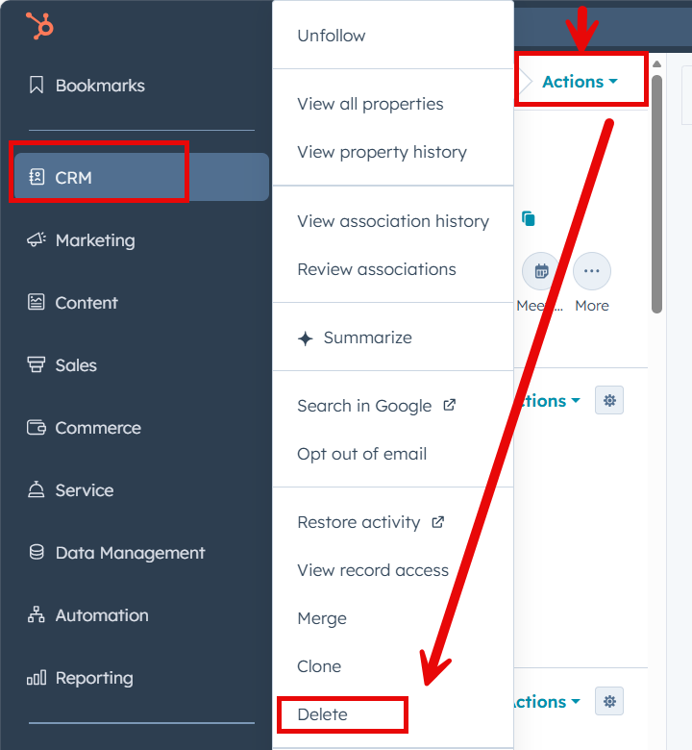
- A Delete Contact? Pop-up box will appear select, Restorable delete.
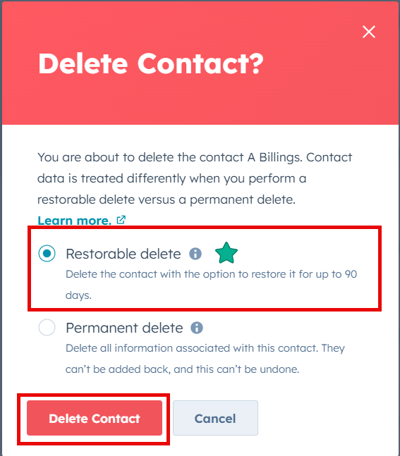

- Click Delete Contact to confirm
  - The contact is now removed from:
    - Active lists
    - Workflows
    - Reports and dashboards
  - The record is stored in HubSpot’s recycle bin for 90 days
  - The contact can be restored during this window if deleted in error

Complete the Contact and Continue Working
After sending the escalation email:
  - Do not make further changes to the contact
  - Do not wait for a response
  - Return to the contact list view (“Non-Dental, International and International Dealer”)
  - Proceed to the next contact in the queue
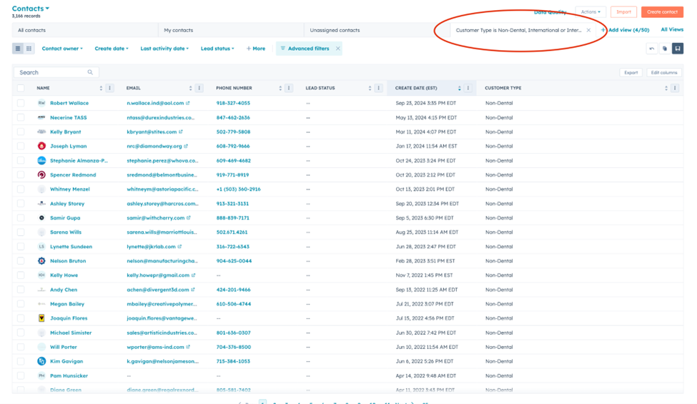

Completion Criteria (What “Done” Means)
A contact in this queue is considered complete when one of the following is true:
- The Customer Type was confidently identified and updated,
OR
- The Customer Type could not be determined, and:
  - The escalation email was sent using the approved template
  - No additional changes were made to the contact
- The contact was deleted using Restorable Delete when removal was required.
Once the list view is empty, the queue is finished for the day.
This is a daily CSS responsibility and part of ongoing maintenance. The expectation is that the queue is reviewed and cleared every day.

Appendix A: Company Relationship Updates
This section is only used when a contact is associated with the wrong company.
Most contacts will NOT require this step.
Use this process only if: The company name is correct, but the contact is linked to the wrong company.
Do not edit the company name when the person has changed jobs. You must update the company relationship instead.
How to Update Company Relationship
1. Locate the Company Section
- Open the contact record
- Look at the right-hand side panel
- Find the Company section
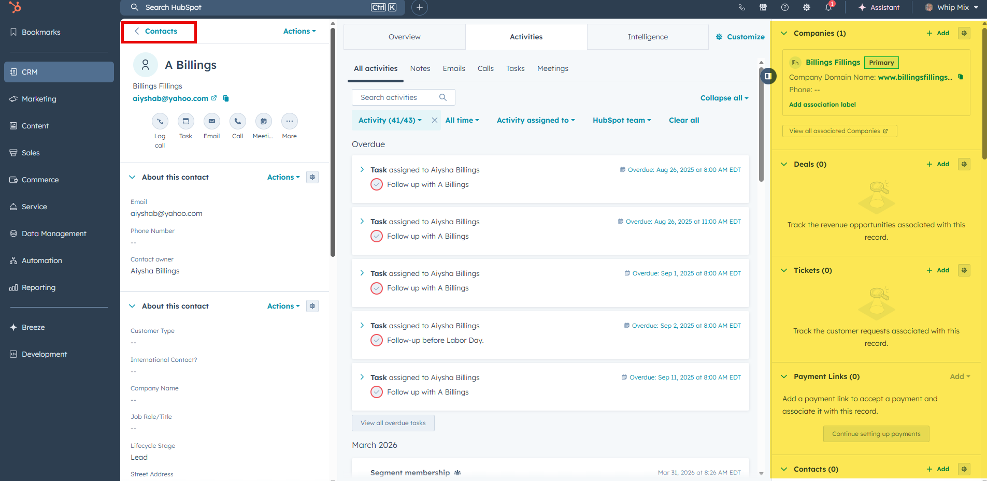

2. Search for the Correct Company
- Click “Add” or “+ Add company”
- In the search bar:
  - Enter the company name (Try variations if needed, Inc, LLC, abbreviations)
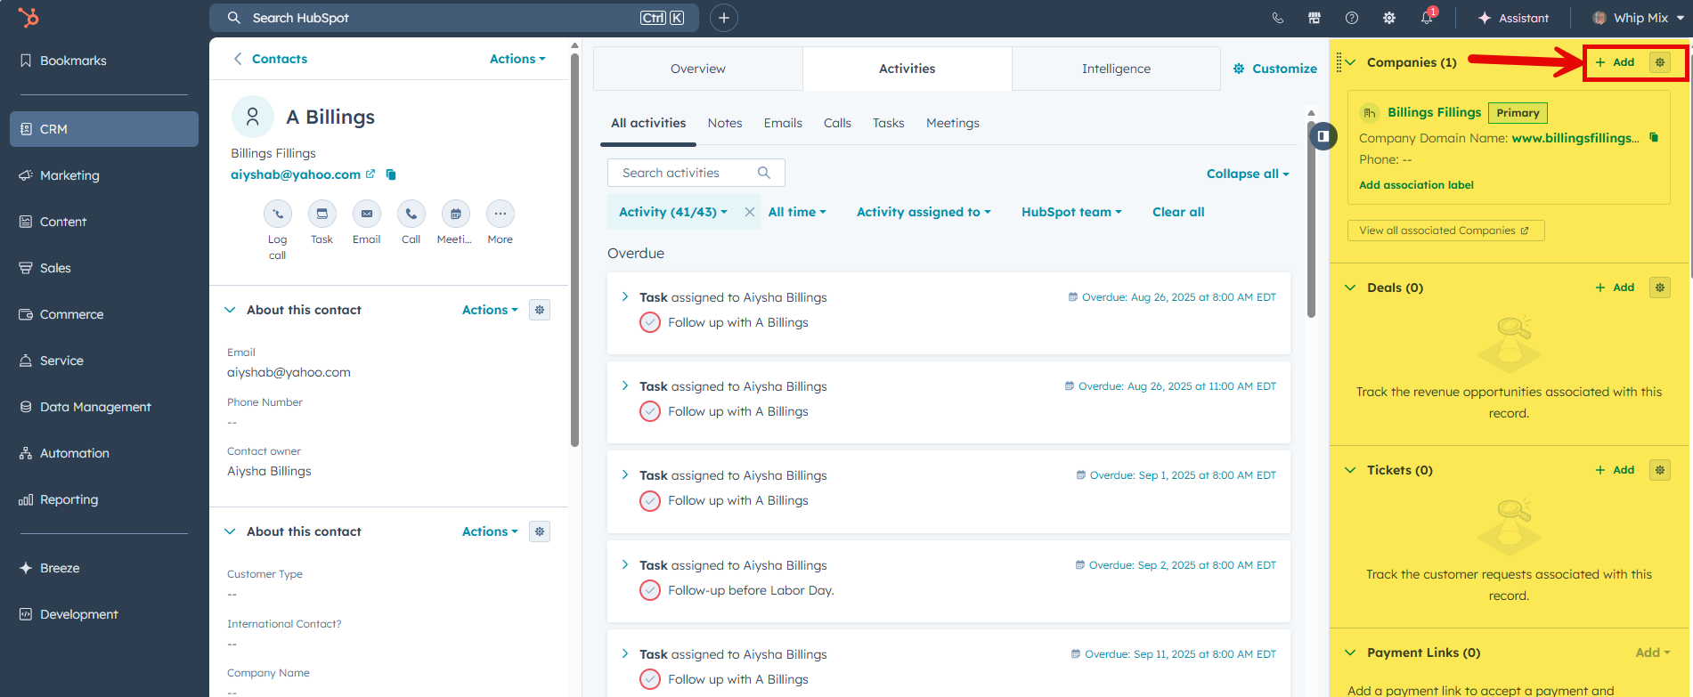
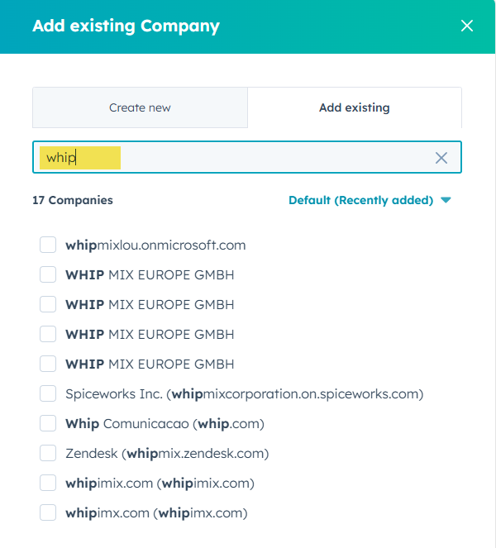
3. Does the Company Exist?
- If Yes:
  - Select the correct company and continue to Step 4.
- If No:
  - Process to create a new company following the process below. Only create a company when it cannot be found and has been clearly verified.
    - For detailed instructions on creating companies, refer to: ..\Create Companies and Contacts\HubSpot- How to Create Companies & Contacts 11.21.25.docx

4. Set Primary Company
- Set the correct company at the Primary company.
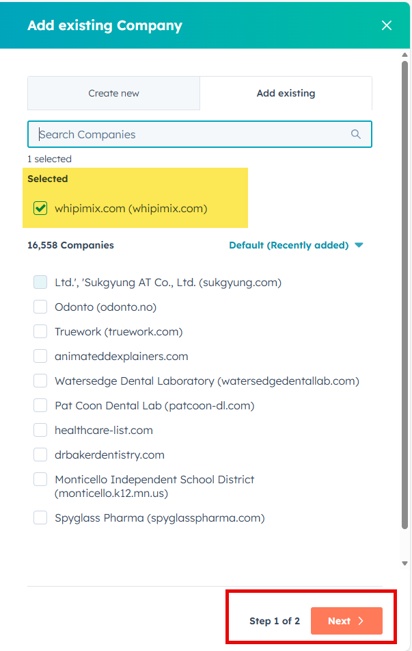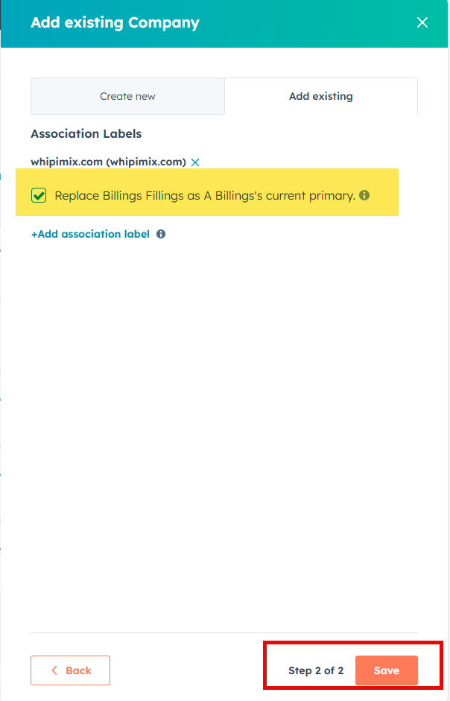

5. Remove Old Company (Only if Confident)
- Remove the previous company only if clearly incorrect. If unsure leave both companies.
